Assignment1

1. created github account.

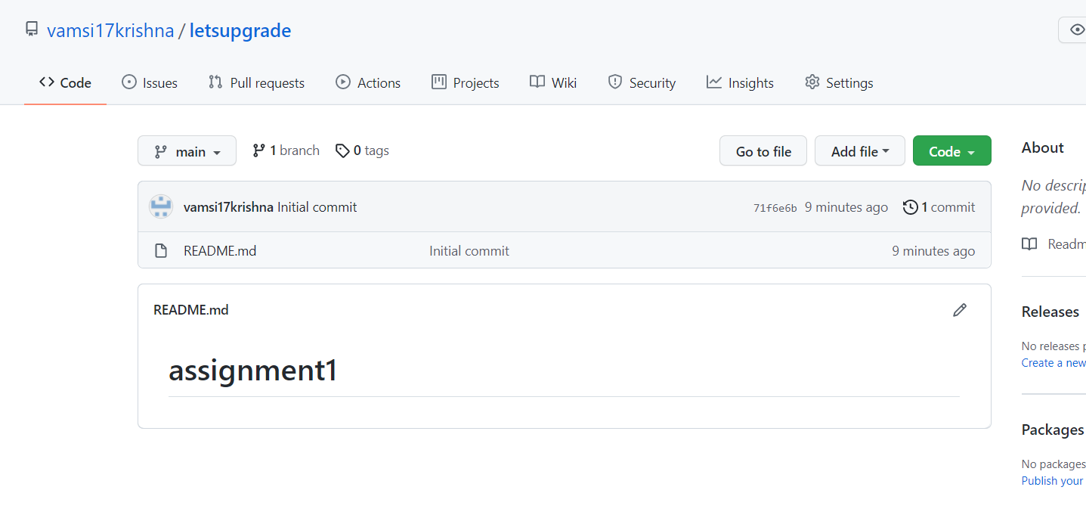

1. Installed git in my local system.

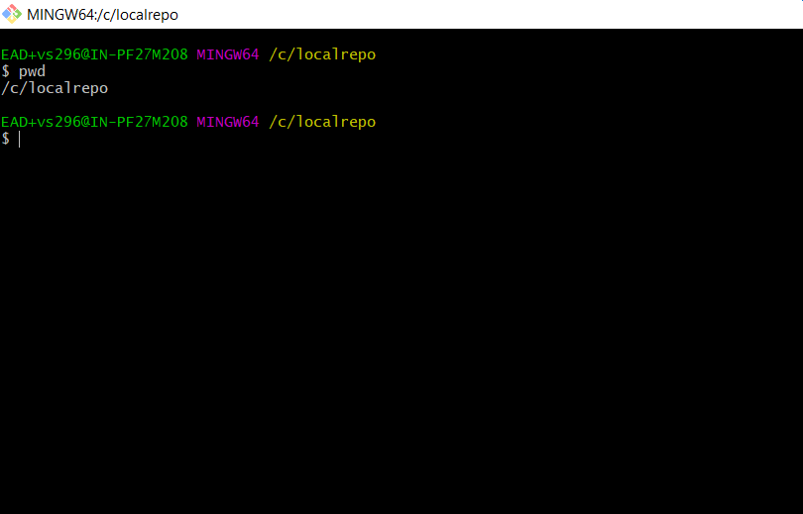

1. Cloned my remote repository into local repository .

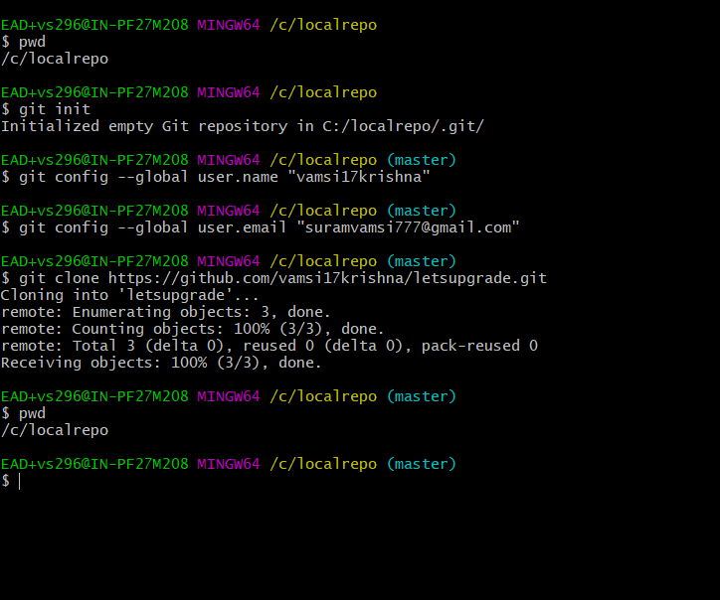

1. Readme file cloned into my local repository .

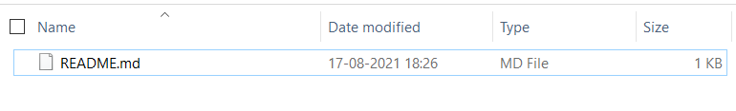

Assignment 2

1. Installed docker

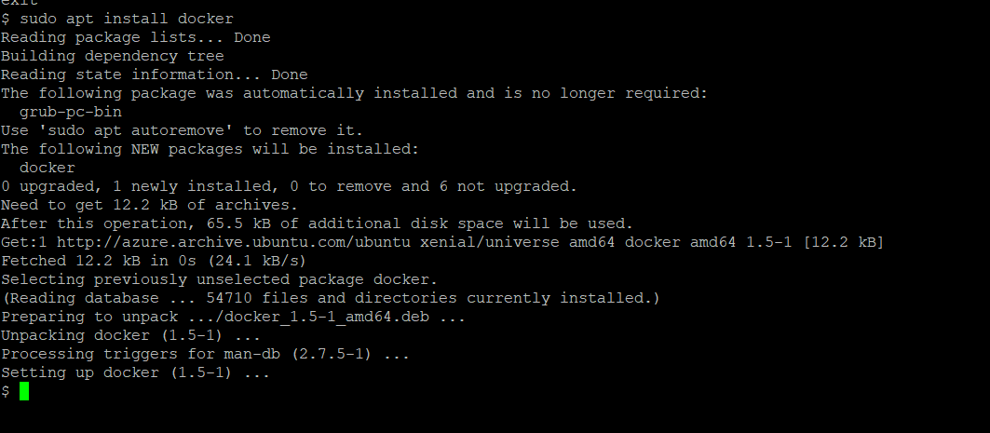

1. Docker –version

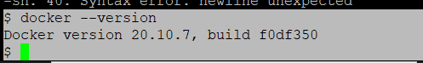

1. Docker start

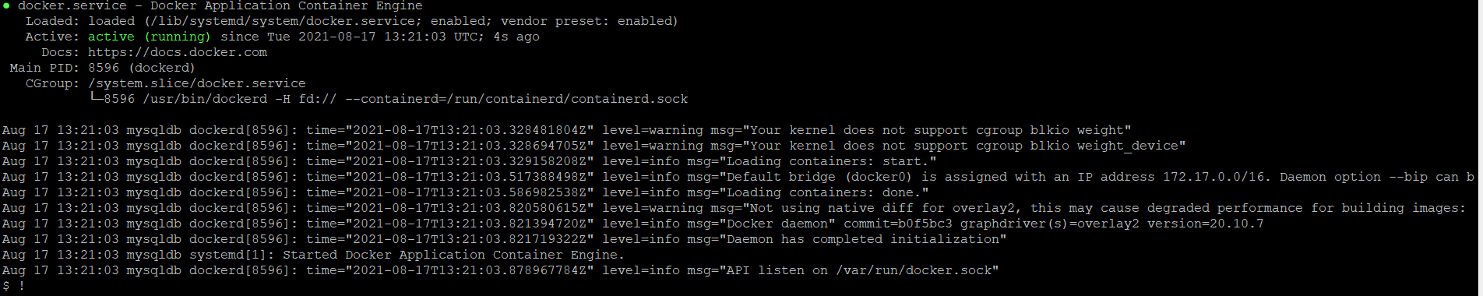

1. Docker stop & docker status

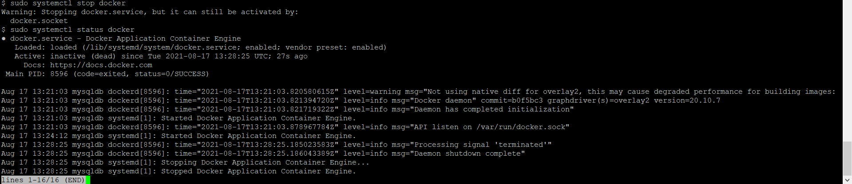

1. Docker hello-world

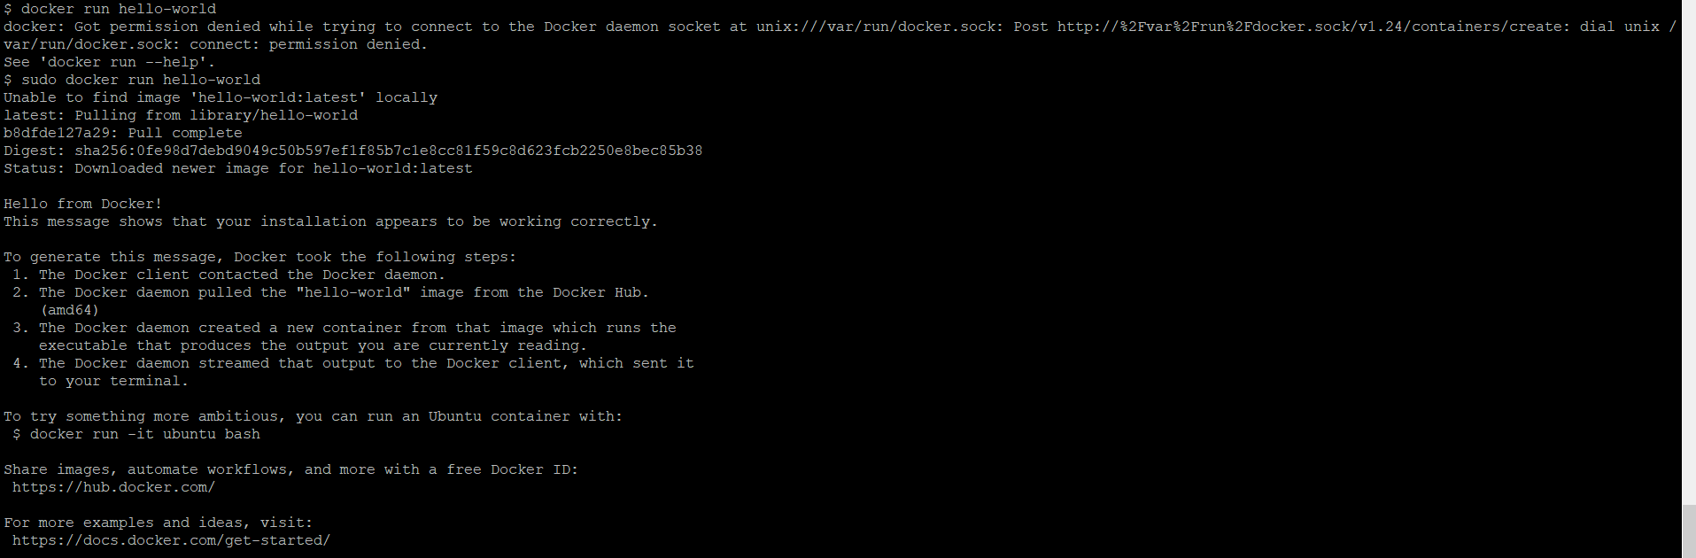

1. Docker run -it ubuntu bash

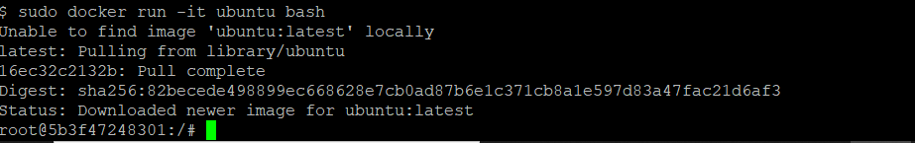

7)working with volumes

Docker volume create



Docker volume inspect

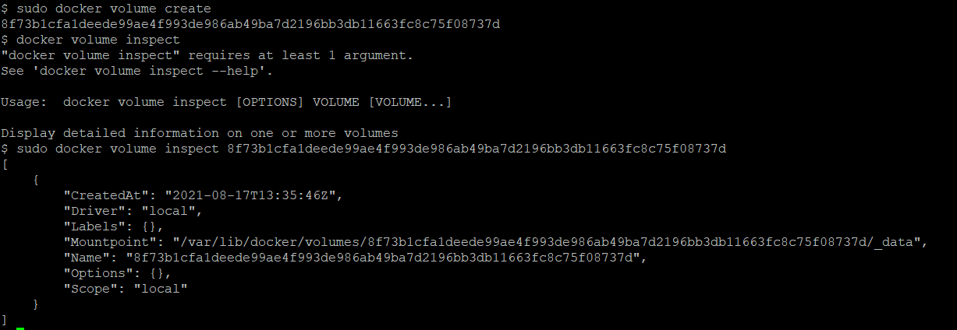

Docker volume remove & docker volume ls

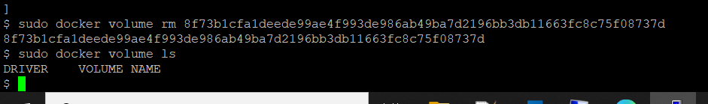

Docker stop

